## Project 01: Hello World

1. **Introduction**

For Raspberry Pi Pico beginners, we will start with some simple things. In this project, you only need a Raspberry Pi Pico and a USB cable to complete the "Hello World!" project, which is a test of communication between Raspberry Pi Pico and the PC as well as a primary project.

1. **Components**

|  |  |
| --- | --- |
| IMG_256 |  |
| Raspberry Pi Pico\*1 | USB Cable\*1 |

1. **Wiring Up**

In this project, we use a USB cable to connect the Raspberry Pi Pico to Raspberry Pi.

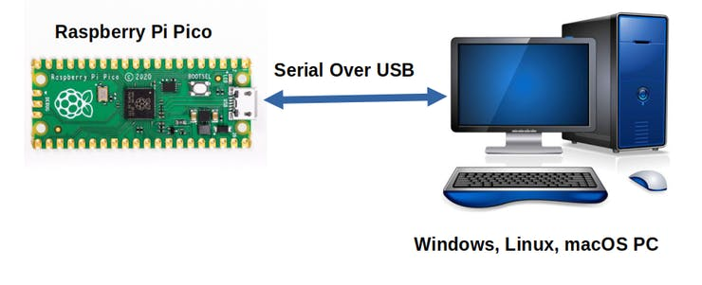

1. **Test Code**

Connect the pico board to the Raspberry Pi, then the Thonny can compile or debug.

Advantages：

1. You can use Thonny software to compile or debug programs.

2. In the "Shell" window, you can view the error information and output results generated during the running of the program, and you can query related functional information online to help improve the program.

Disadvantages：

1. You have to connect the pico board with the Raspberry Pi then run the Thonny.
2. If disconnecting pico board and the Raspberry Pi and rebooting them, programming may fail.

Open Thonny and click“Open...”

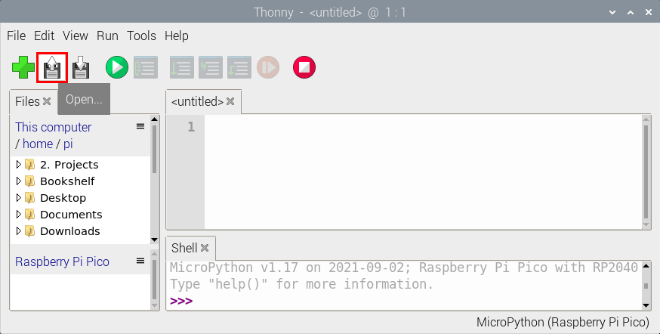

Then click“This computer”

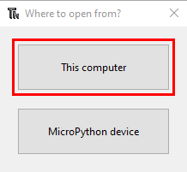

Select“Project\_01\_HelloWorld.py”and click“OK”.

Check the code in the folder KS3020 Keyestudio Raspberry Pi Pico Learning Kit Ultimate Edition\3. Raspberry Pi System\Python\_Tutorial\2. Projects

You can move the code anywhere. We copyt the 2.Projects.zip to the pi folder of the Raspberry Pi system.

Path:home/pi/2. Projects

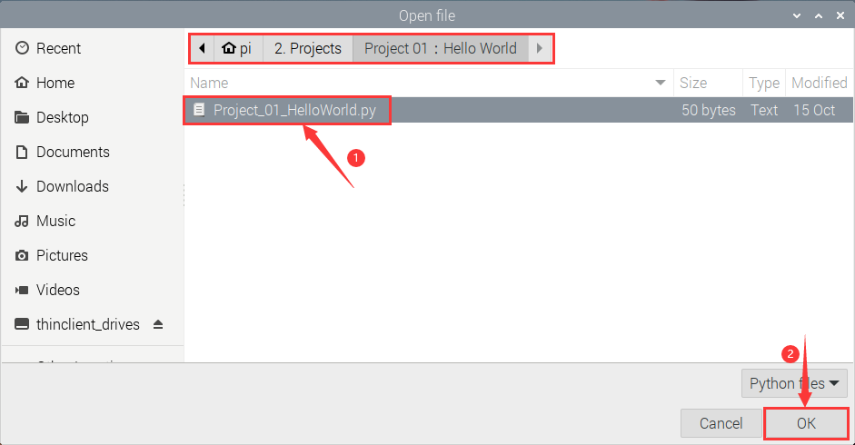

Click to run the code Hello World!. Then Welcome Keyestudio will be displayed on the Shell.

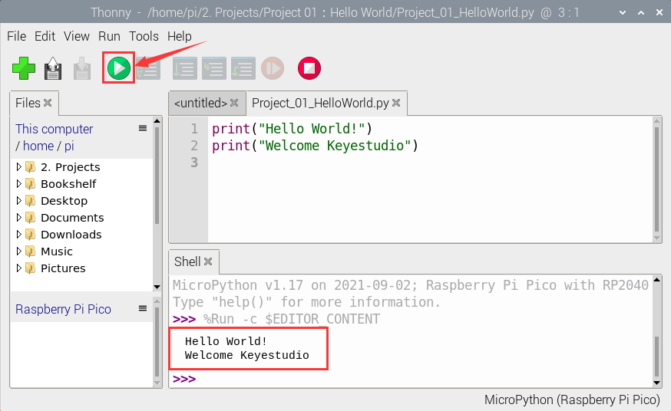

**Exit online running**

When running online，click“Stop /Restart backend”to exit

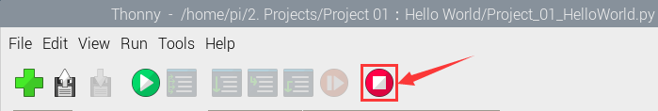

**Test Code：**

|  |
| --- |
| print("Hello World!")  print("Welcome Keyestudio") |